The Ministry of Health is currently advising New Zealanders “to act as if Omicron is circulating in their community”.
Kidney Health New Zealand has therefore put together some updated advice for people living with kidney disease.

Importantly, things have improved since the start of the pandemic for people with kidney disease:
- COVID-19 vaccines work for people living with kidney disease, and have a good safety profile,
- There are new treatments that work in COVID-19, often preventing serious illness and death,
- People with kidney disease do better now: they are less likely to catch COVID-19 and less likely to have severe illness
- The Omicron variant is less likely to cause severe disease than previous variants, although severe cases do still occur

What is my risk of COVID-19?
Your risk depends on your what is happening in your community, what activities you’re doing, and your own health.
Community – as the number cases in your local community increase, the chance of catching COVID-19 increase. Scanning in to places you visit using the NZ COVID Tracer app , turning on Bluetooth tracing in the app, and keeping a safe distance from people you do not know while out and about can all help if there is COVID-19 in your local community.
Activities – There is a higher risk of catching COVID-19 in crowded indoor areas with poor ventilation. Adapting your activities and environment can change your risk of catching COVID-19 (see graphic).
Health – There are a number of personal factors that increase the risk of developing severe illness from COVID-19. Many of these factors are not modifiable e.g. severity of kidney disease. It can be helpful to understand whether you are at lower, moderate or higher risk of developing a severe illness from COVID-19 so that you can decide what steps to take to reduce your risk of catching COVID-19.

Risk of catching Covid:
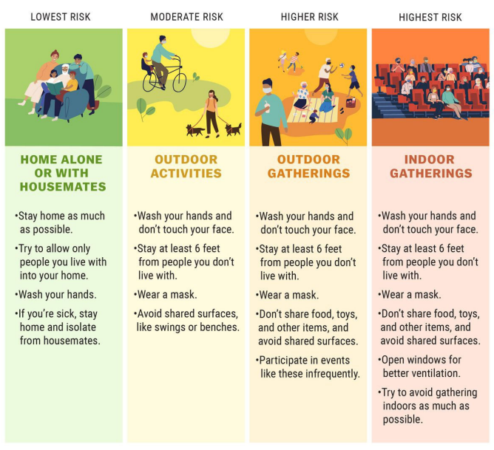

How can I reduce my risk of COVID-19?
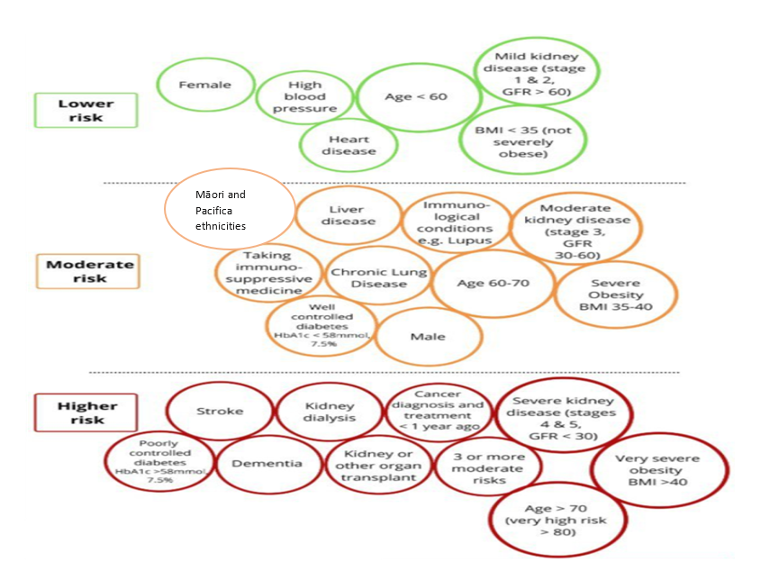

When COVID-19 is circulating in the community it is not possible to reduce the risk of catching COVID-19 to zero – but it is possible to reduce the risk of catching COVID-19, and to reduce the chance of becoming seriously ill after catching the virus.
Changing behaviours can reduce risk, and you can take different steps according to the current risk in your community and the options you have available. Behaviour changes could include:
REDUCE risk e.g. visiting places at less risky times if you can e.g. avoiding busy times on public transport and at the supermarket
TRANSFERRING risk by transferring tasks to other people if you can e.g. ask others to help with shopping
AVOID risk e.g. avoid crowded indoor spaces with lots of strangers
How can I reduce my risk of COVID-19 at home and when I’m out?
Vaccination – getting the vaccine can protect you from becoming very unwell if you get COVID-19.
Kidney transplant patients in the UK who received 2 vaccine doses were 183-times less likely to die than unvaccinated transplant patients. For people with advanced kidney disease (pre-dialysis or on dialysis) who were waiting for a transplant, deaths from COVID-19 fell from just over 1% in unvaccinated patients to zero after 2 doses of the vaccine.
Recommend that members of your household also get vaccinated, to reduce the risk to themselves, to you, to your loved ones, and to the community.
Details about when to get your vaccine, and how to get 3rd doses and booster doses, are included on the final page.
Continue to take all prescribed medications as normal and make sure you have two weeks of medications on hand
Improve ventilation – choose outdoor spaces if possible, and open windows to increase fresh air flow inside if you can
Wash your hands or use hand sanitiser - Washing your hands is one of the easiest ways to keep yourself safe. Wash often with soap for 20 seconds. Then dry your hands completely. Using hand sanitiser that has at least 60% alcohol is also effective at killing germs and viruses. These kill the virus by bursting its protective bubble.
Clean or disinfect shared surfaces regularly - This includes frequently touched items like door handles, light switches and phones. Use an antiviral disinfectant and follow instructions. Remember to store cleaners and disinfectants safely.
Keep your distance from people you do not know - You are not required to maintain physical distance from others in the traffic light system. But it is still worthwhile keeping a safe distance from people you do not know while out and about.
Practice social distancing if that feels right for you and your friends – consider asking visitors to your home to wear masks, and to keep up-to-date with their vaccines including booster doses.
Speak to your employer about what temporary arrangements they can make to reduce your risk – your employer may be able to perform a risk assessment with you to make reasonable adjustments whilst COVID-19 is circulating in the community e.g. working from home wherever possible, or flexible start times to avoid peak time travel on public transport, or moving away from public facing roles to other useful roles in the business. Your employer may also be able to support safe best practice in the workplace e.g. ensure good ventilation, use of face masks and social distancing in more crowded areas, and encouraging other employees to carefully apply COVID-19 safety measures.
Cough or sneeze into your elbow or cover your mouth and nose with tissues. Put tissues in a bin immediately, then wash your hands thoroughly.
Avoid touching your eyes, nose and mouth - to prevent the virus entering the body.
Stay home if you are sick – there is advice on the next pages about how to prepare for a case of COVID-19, and what to do if you develop symptoms of COVID-19
How can I prepare for COVID-19?

If you receive regular treatment from a kidney unit (e.g. dialysis or recent transplant) then keep the contact details of your kidney team, so that you can let them know if you have to isolate or develop symptoms of COVID-19.
https://www.kidney.health.nz/Patient-Information/Dialysis-Unit-Contact-Information/

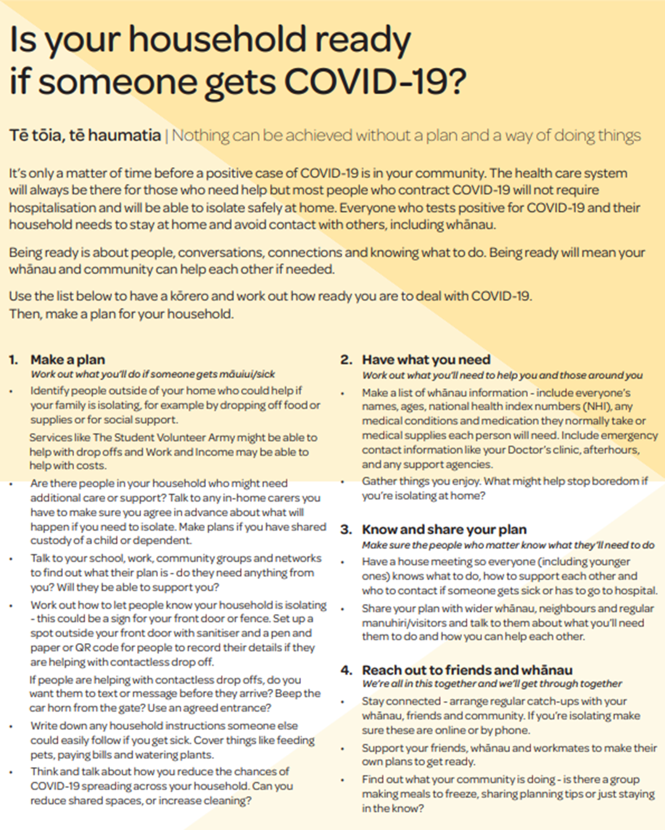
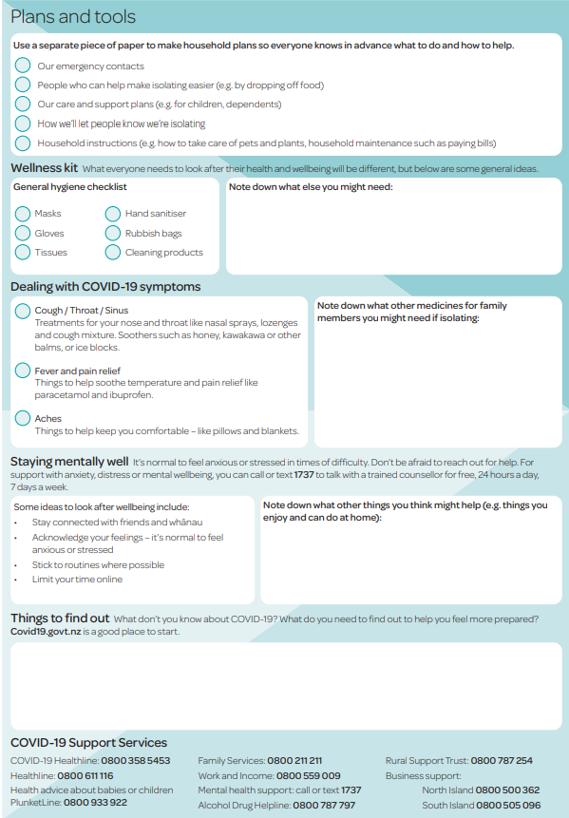

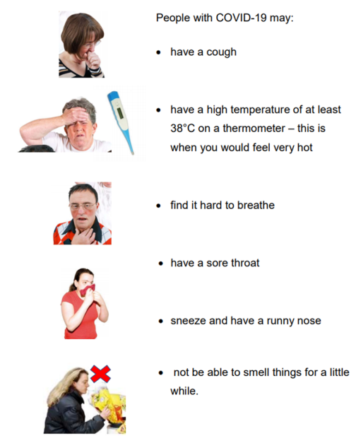
What should I do if I have symptoms of COVID-19?

What to do if you have COVID-19 symptoms:
- Get a test
  - COVID-19 tests are free
  - Find your nearest test centres at the “Healthpoint” website: https://www.healthpoint.co.nz/covid-19/?options=anyone
- If you receive regular treatment from a kidney unit (e.g. dialysis or recent transplant) then let your kidney team know
- Stay home until you get a negative result
Even if you have had your vaccination, you should still get tested for COVID-19 if you develop symptoms

What to do if you have a positive test for COVID-19 :
- Your doctor or a health professional will be in contact with you
- If you receive regular treatment from a kidney unit (e.g. dialysis, recent transplant) then let your kidney team know
- Stay home (unless a health professional tells you otherwise)
- Anyone you live with will need to stay home for the entire time you and anyone else in your household who tests positive are isolating. Household members of a COVID-19 case are Close Contacts and will need to get a series of tests. Household members will need to isolate for longer than you.
- If you are self-isolating at home you will have support from local healthcare providers to meet your health, welfare and wellbeing needs. You may go into a MIQ facility which can meet your health and welfare needs and to prevent the risk of spreading COVID-19 in your whānau and community.
- In some cases, people with COVID-19 become very unwell and need to go to hospital. In this case, the hospital will take the steps needed to isolate you while giving you the medical care you need.

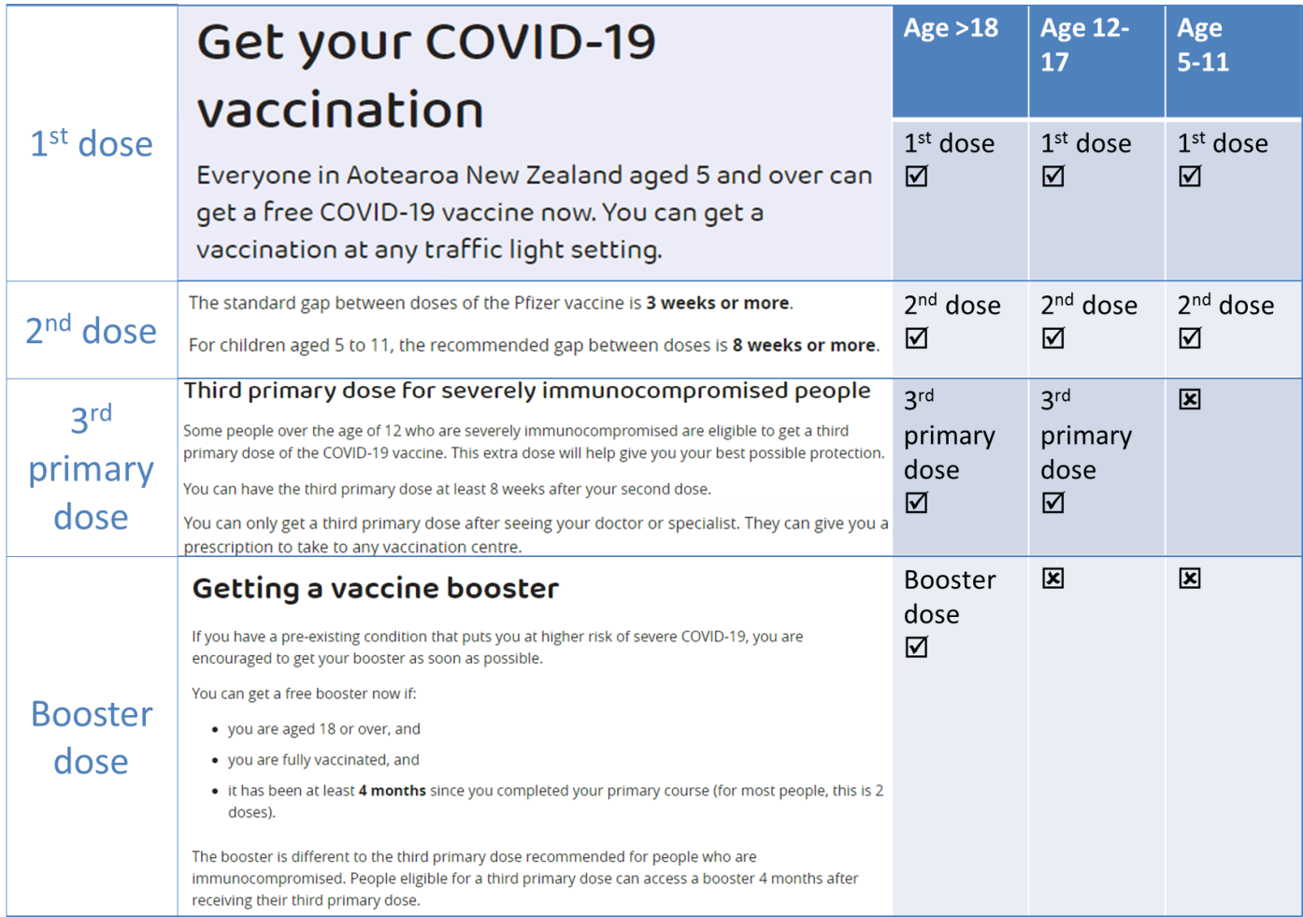
3

Where to get more advice:
Unite Against COVID-19: https://covid19.govt.nz/
Kidney Care UK: https://www.kidneycareuk.org/news-and-campaigns/news/coronavirus-covid-19-guidance-people-kidney-disease/
Kidney Health NZ: https://www.kidney.health.nz/
Kidney Health Australia: https://kidney.org.au/covid-19-and-your-kidneys
World Health Organisation: https://www.who.int/emergencies/diseases/novel-coronavirus-2019/advice-for-public

Where to get more advice on specific topics:
People at higher risk of severe illness from COVID-19: https://covid19.govt.nz/prepare-and-stay-safe/about-covid-19/people-at-higher-risk-of-severe-illness-from-covid-19/
Vaccine advice if you have a health condition: https://covid19.govt.nz/covid-19-vaccines/get-the-facts-about-covid-19-vaccination/vaccine-advice-if-you-have-a-health-condition/#if-you-are-immunocompromised
Keep up healthy habits: https://covid19.govt.nz/prepare-and-stay-safe/keep-up-healthy-habits/
Masks: https://covid19.govt.nz/prepare-and-stay-safe/keep-up-healthy-habits/wear-a-face-mask/how-to-wear-a-face-mask-safely/ and https://www.who.int/emergencies/diseases/novel-coronavirus-2019/question-and-answers-hub/q-a-detail/coronavirus-disease-covid-19-masks
Dialysis: Some general advice for dialysis patients from Kidney Health Australia is here: https://kidney.org.au/covid-19-and-your-kidneys/covid-19-and-kidney-transplants . Advice about local protocols (e.g. adapting dialysis shifts when necessary) may be available from your dialysis team.
Transplant: Some general advice for dialysis patients from Transplant Australia is here: https://transplant.org.au/living-with-your-transplant/self-care/covid-19-and-transplant-recipients/ . Advice about local protocols (e.g. attending clinic) may be available from nursing and medical staff at your transplant clinic.

